**Flashcards Project Portfolio**

Table of Contents

**1. Analysis** 3

*1.1. Problem Overview:* 3

*1.2. Existing Solutions:* 3

1.2.1 Solution 1: 3

*1.3. Market Research:* 4

*1.4. Objectives:* 4

**2. Design** 5

*2.1 IPSO Diagram:* 5

*2.2 Data Dictionary:* 5

*2.3. Project Draft:* 5

2.3.1. Pseudo Code: 5

2.3.2. Flowcharts: 5

*2.4. Class Diagram:* 5

*2.5. User Interface Design:* 5

**3. Technical Solution** 6

*3.1. Completeness of Solution:* 6

*3.2. Technical Skills:* 6

**4. Testing** 7

*4.1. Test Plan:* 7

4.1.1. Expected Tests: 7

4.1.2. Test Data: 7

4.1.3. Test Results: 7

*4.2. Test Done:* 7

**5. Evaluation** 8

# **1. Analysis**

## *1.1. Problem Overview:*

My project is going to be about a flash card quiz. It is going to provide questions to the user to test their knowledge.

## *1.2. Existing Solutions:*

### 1.2.1 Solution 1:

Seneca Learning:

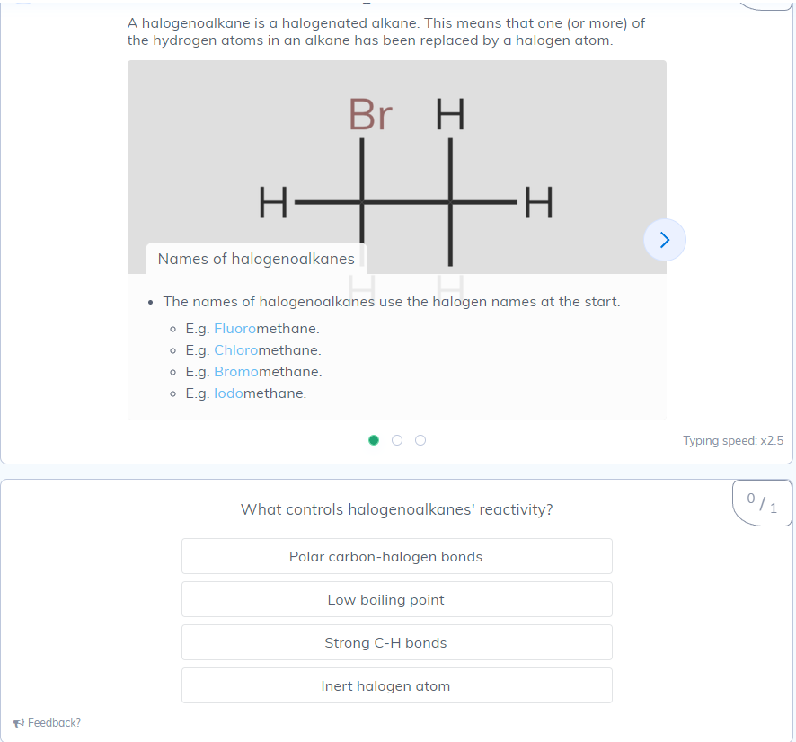

* Seneca gives the user information in forms of flashcards.
* It then asks question in either multiple choice, fill in the gaps, or sliders.
* When done, it gives you a percentage of answers correct.
* It has a user interface that makes it look nice and easy to use.

## *1.3. Market Research:*

<https://forms.office.com/e/F3hSYKQLdm>

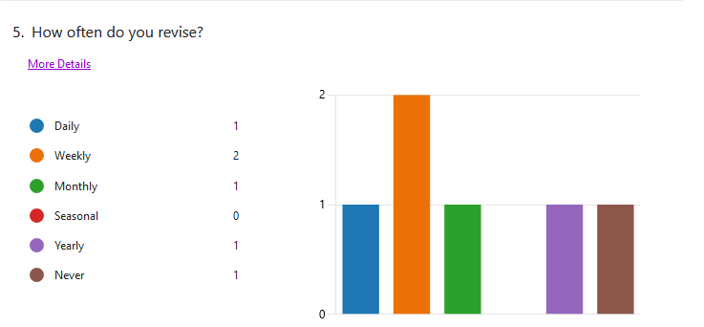

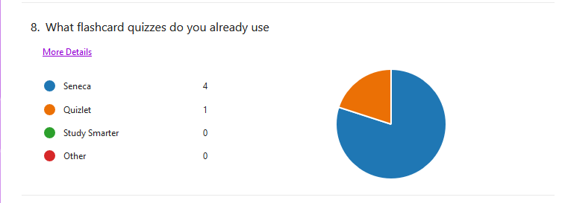

## *1.4. Objectives:*

1. The basic parts of the project are:
   1. It must be able to read/modify .txt files
   2. It must be able to create/delete .txt files
   3. Link cards out of keywords and definitions (in .txt file)
   4. Make multiple choice questions about the cards.
      1. Give the definition and ask for keyword
      2. Give the Keyword asks for definition
      3. Questions will be in a random order
      4. If done correctly multiple times it will remove it from the .txt and add it to a different completed .txt file
   5. A menu to allow re/starting or exiting of the quiz
   6. A score system to track users correct answers
   7. A timer to see how long it takes, in the form h:m:s
2. The project would be nice with:
   1. An interactive GUI
   2. Multiple .txt files for different subjects and being able to choose between them

# **2. Design**

## *2.1 IPSO Diagram:*

## *2.2 Data Dictionary:*

## *2.3. Project Draft:*

### 2.3.1. Pseudo Code:

### 2.3.2. Flowcharts:

## *2.4. Class Diagram:*

## *2.5. User Interface Design:*

# **3. Technical Solution**

## *3.1. Completeness of Solution:*

## *3.2. Technical Skills:*

# **4. Testing**

## *4.1. Test Plan:*

### 4.1.1. Expected Tests:

### 4.1.2. Test Data:

### 4.1.3. Test Results:

## *4.2. Test Done:*

# **5. Evaluation**